- A light ray is incident perpendicularly to one face of a 90° prism and is totally internally reflected at the glass-air interface. If the angle of reflection is 45°, we conclude that the refractive index n - [aieee-2004]
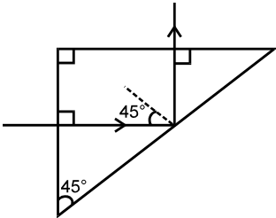
  - (b)
(c) (d)
- Two point white dots are 1 mm apart on a black paper. They are viewed by eye of pupil diameter 3 mm. Approximately, what is the maximum distance at which these dots can be resolved by the eye?[Take wave length of light =500 nm]
  - 1 m (b) 5 m
- (c) 3 m (d) 6 m
[AIEEE 2005]
- A transparent solid cylindrical rod has a refractive index of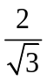. It id surround by air. A light ray is incident at the mid-point of one end of the rod as shown in the figure.
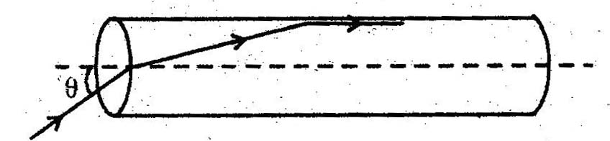
The incident angle for which the light ray grazes along the wall of the rod is:
  - Sin⁻¹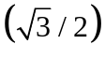 (b) sin⁻¹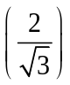
(c) sin⁻¹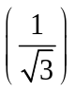 (d) sin⁻¹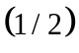
[AIEEE-2009]
- When an unpolarized light of intensity 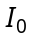 is incident on a polarizing sheet, the intensity of the light which does not get transmitted is
Zero (b)
(c) 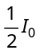 (c) 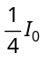
[AIEEE 2005]
- In a young’s double slit experiment the intensity at a point where the path difference is being the wavelength of the light used) is. If denotes the maximum intensity, is equal to:
  - (b)
(c) (d)
[AIEEE 2007]
- Radio wave diffract around building although light waves do not. The reason is that radio waves
Travel with speed larger than c
Have much larger wavelength than light
Carry news
Are not electromagnetic waves
[AMU 2000]
- A beam of unpolarized light of intensity is passed through a Polaroid A and then through another Polaroid B which is oriented so that its principal plane makes an angle of 45º relative to that of A. The intensity of the emergent light is:
  - (b)
(c) (d)
[AIEEE 2013]
- In a series resonant LCR circuit, the voltage across R is The resonant frequency At resonance the voltage across L is
(b)
(c) (d)
[AIEEE 2006]
- An inductor of inductance L and resistor of resistance R are joined in series and connected by a source of frequency. Power dissipated in the circuit is
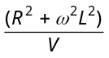 (b) 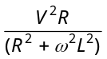
(c) 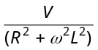 (d) 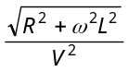
[AIEEE 2002]
- If the binding energy of the electron in a hydrogen atom is 13.6 eV, the energy required to remove the electron from the first excited state of 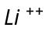 is
122.4 eV (b) 30.6 eV
(c) 13.6 eV (d) 3.4 eV
[AIEEE 2003]
- If 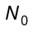 is the original mass of the substance of half life period 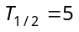 years, then the amount of substance left after 15 years is
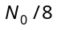 (b) 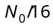
(c) 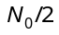 (d) 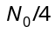
(a) (b) (c) (d)
The diagram shows-the energy levels for an electron in a certain atom. Which transition shown represents the emission of a photon with the most energy
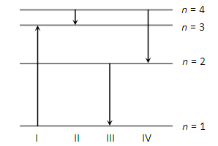
I (b) II
(c) III (d) IV
[AIEEE 2005]
- An alpha nucleus of energy bombards a heavy nuclear target of charge Then the distance of closest approach for the alpha nucleus will be proportional to
(b)
(c) (d)
[AIEEE 2006]
- Suppose an electron is attracted towards the origin by a force where ‘k’ is a constant and ‘r’ is the distance of the electron from the origin. By applying Bohr model to this system, the radius of the orbital of the electron is found to be and the kinetic energy of the electron to be Then which of the following is true
[AIEEE 2008]
- The half life of a radioactive substance is 20 minutes. The approximate time interval between the time when of it has decayed and time when of it had decayed is
7 min (b) 14 min
(c) 20 min (d) 28 min
[AIEEE 2011]
- The time taken by a photoelectron to come out after the photon strikes is approximately
(b)
(c) (d)
[ AIEEE 2006 ]
- The anode voltage of a photocell is kept fixed. The wavelength of the light falling on the cathode is gradually changed. The plate current 1 of the photocell varies as follows [ AIEEE 2006 ]
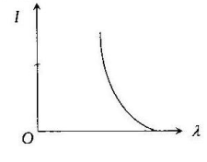(b) 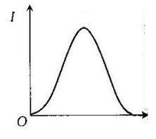
(c) 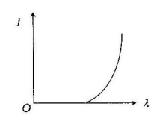(d) 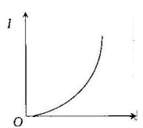
(a)(b) (c) (d)
- Light of two different frequencies whose photons have energies and respectively, successively illuminates a metal of work function . The ratio of maximum kinetic energy of the emitted electron will be
(a) 1 : 5 (b) 1 : 4
(c) 1 : 2 (d) 1 : 1
[AIEEE 2002]
- The surface of a metal is illuminated with the light of The kinetic energy of the ejected photoelectrons was found to be The work function of the metal is
(b)
(c) (d)
[ AIEEE 2009 ]
- At , silicon behave as –
  - super conductor
  - conductor
  - Insulator
  - none of these
[aieee-2002]
- When p–n junction diode is forward biased,
then –
  - both the depletion region and barrier height are reduced
  - the depletion region is widened and barrier height is reduced
  - the depletion region is reduced and barrier height is increased
  - both the depletion region and barrier height
are increased
[aieee-2004]
- If in a p-n junction diode, a square input signal of 10 V is applied as shown. Then the output signal across RL will be –
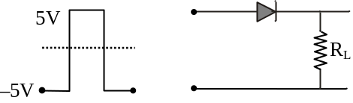

  - 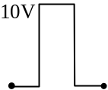 (b) 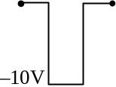
(c) 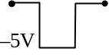 (d) 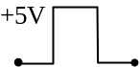
[AIEEE-2007]

